|  |
| --- |
| Circle Language Spec: Commands |

## Sub-Commands in a Diagram

The concept of sub-commands was already explained in the article *Sub-Commands*. The current article demonstrates the concept in a diagram.

Sub-commands are active commands contained inside a parent command. You can encounter them inside any command symbol: both active and inactive commands symbols can contain sub-commands. The sub-commands are *active* commands: command calls, active clauses or active command references.

Below is a picture of two sub-commands inside an inactive command:

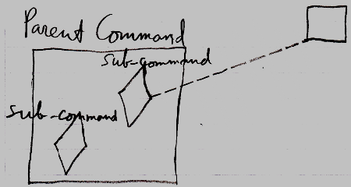

The Parent Command is an inactive command, because it is a square. In the diagram above, the Parent Command contains two sub-commands. The sub-commands are displayed as diamond shapes. One of the sub-commands is a call, because it has a dashed line going outside the Parent Command, tying the sub-command to its command definition. The other sub-command is an *active clause*, because it does not redirect its command definition.

Below is a picture of two sub-commands inside an active command:

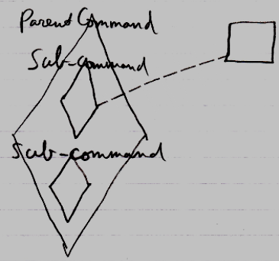

It is the same picture as the other diagram, only now the Parent Command is an executable command symbol, not an inactive command.